Architecture design

System Architectural Approach

The MVC Architecture Pattern

The Model-View-Controller (MVC) is an architectural pattern which separates presentation and interaction from the system data. The system is structured into three logical components that interact with each other:
      - Model: manages the system data and associated operations on that data
      - View: defines and manages how the data is presented to the user
      - Controller: manages user interaction (e.g., key presses, mouse clicks, etc.) and passes these interactions to the View and the Model

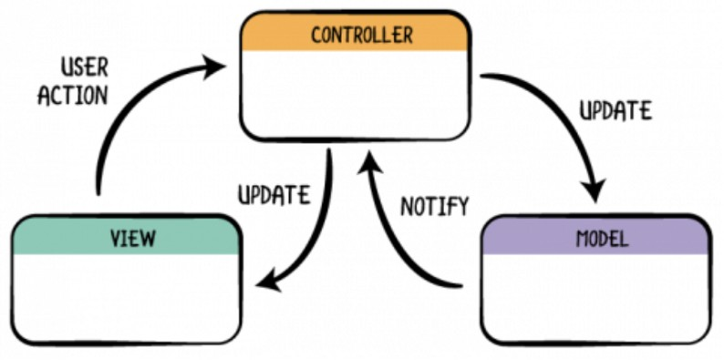

Figure 13: MVC Diagram

The Model-View-Controller (MVC) should be used when there are multiple ways to view and interact with data. It can be also used when future requirements for interaction and presentation of data are unknown.
The MVC pattern allows the data to change independently of its representation and vice versa. It also supports representation of the same data in different ways with changes made in one representation shown in all of them. However, there can be some additional code and code complexity when the data model and interactions are simple.

Apply MVC pattern to implement the desired system

Our goal is to create a web application for restaurant business, so the architectural diagram may look like this.

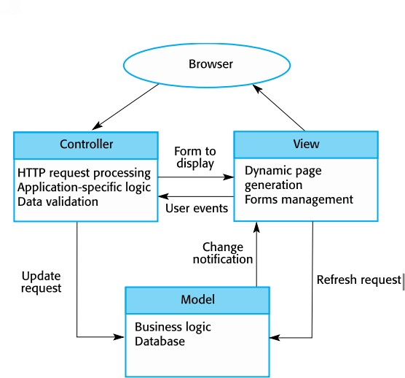

Figure 14: Conceptual view of web-based MVC

The user can use the system via Browser. Depend on the type of user, the View can be different. With customers, they can see the home page to choose to see menu and order food or to enter information into a table reservation form to reserve a table. With clerks, they can access to clerk’s working dashboard to see and manage the order list, reservation list. With managers, they can access to manager’s working dashboard to manage the menu.
The Controller of the system will manage user interactions and pass these interactions to the View and the Model. Customers may place an order and the Controller will send the update request to Model to add the record to database, the same thing happens when Customers reserve a table. Clerks may reject or confirm the orders, reservations and the Controller will also send an

update request to the Model to update database. Manager may change some item in the menu, the Controller send an update request to the Model to update database and the Model will send change notification to the View and the View will send refresh request to the Model to update new menu to the View (now Customers will also see the changes).

